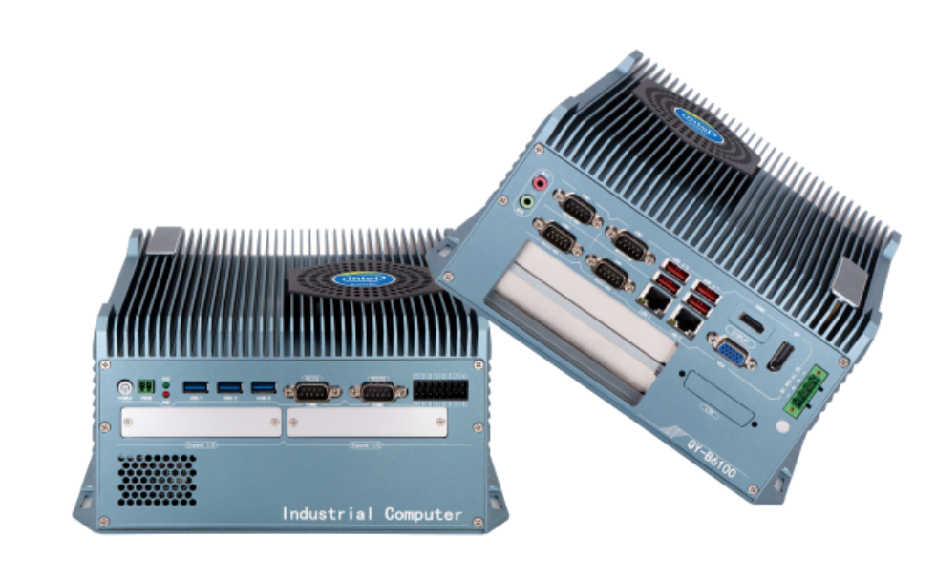
Industrial Mini PC
QY-B6100
Desktop CPU Series

Products Features:
- Industrial-Grade Embedded Fanless Mini PC
- Intel H670 Chipset
- Intel Celeron, Pentium and Core 12/13/14th-i3/i5/i7/i9 CPU
- 2*LAN, 7*USB, 6*COM, 1*HDMI, 1*VGA, 1*DP, 14*GPIO
- 1*Mini PCIE+1*M.2 Expansion Slots, Support 4G/5G and WIFI Module
- 1*PCIE 16X+1*PCIE 1X or 2*PCI Slots
- 2*Multifunctional Expansion Daughter Card
- DC 19-36V Power Input With Overvoltage Protection
- -30℃~70℃ Temperature Can Keep 24/7 Work Stably
- Anti-Static, Anti-Pulse, Anti-Surge, Anti-Radiation
QY-B6100
1.Mother Board Specification:
Model | QY-B6100
Chipset | H670
CPU | Celeron G Series / Pentium Gold Series  Core 12 / 13 / 14th-i3 / i5 / i7 / i9
Memory | 2*DDR IIII RAM Slots, Up to 64GB
Storage | 1*MSATA SSD Slot  1*M.2 NVME SSD Slot  1*SATA SSD Slots
Display | 1*HDMI: Resolution up to 4096*2304@60Hz  1*DP: Resolution up to 4096*2304@60Hz  1*VGA: Resolution up to 1920*1200@60Hz
Expansion | 1*Mini PCIE Slot+1*M.2 Slot, Support 4G/5G and WIFI module  1*PCIE 16X+1*PCIE 1X or 2*PCI
Ethernet | 2*Intel i211V LAN Chip (10 / 100 / 1000 Mbps, RJ-45 Type)
USB | 4*USB 3.1+3*USB 3.0 (Type-A)
COM | 4*RS-232 / 422 / 485+2*RS-232 (DB9 Type)
Audio | 1*Line-In+1*Line-Out
GPIO | 14 ports GPIO (7*GPI+7*GPO, Phoenix terminal type)
Daughter Card | 2*Daughter Card Slots，Support expansion I/O interfaces and funcational slots

QY-B6100
2.Device Specification:
Watch Dog | Support
Power Input | DC 19-36V With Overvoltage Protection
Power Input | Support Auto-Start
Power Input | 4 Pin Phoenix Terminal Type DC Plug
Working Temperature | -30℃~70℃, Support 24/7 Working
Structure | Fully Enclosed Aluminum Alloy Material
Heat Dissipation | Fan Design  (Fanless design chassis, optional)
Installation | Desktop / Embedded / Wall Mount
Size | 236mm*220mm*118mm
Power Consumption | Max to 240W
System | Windows and Linux

QY-B6100
3.Daughter Card Specification:
COM Port-2 | 2*RS-232 / 485 (DB9 type)
COM Port-6 | 4*RS-232 / 485+2*RS-232 (Phoenix terminal type)
Ethernet Port-2 | 2*Intel i211V LAN Chip (RJ-45 type)
Ethernet Port-4 | 4*Intel i211V LAN Chip, Support POE function (RJ-45 type)
10G Ethernet Port-2 | 2*10Gbps Ethernet Ports
USB Port-4 | 4*USB 3.0 (Type-A)
GPIO Port-14 | 14 ports GPIO, 7*GPI+7*GPO, 0-3.3V (Phoenix terminal type)
DIDO Port-16 | 16 ports DIDO, 8*DI+8*DO, 24V (Phoenix terminal type)  Comes with 4*RS-485 COM ports (Phoenix terminal type)
Mini PCIE Slot-2 | 2*Mini PCIE slots, Support 4G and WIFI module
M.2 Slot-1 | 1*M.2 Key-B slot, Support 5G module
M.2 NVME SSD Slot-1 | 1*M.2 NVME SSD slot
SATA SSD Slot-1 | 1*SATA 3.0 SSD Slot, Support RAID 1
CAN Port-2 | 2*CAN interfaces (Phoenix terminal type)
UPS battery | 1.2AH or 4.8AH
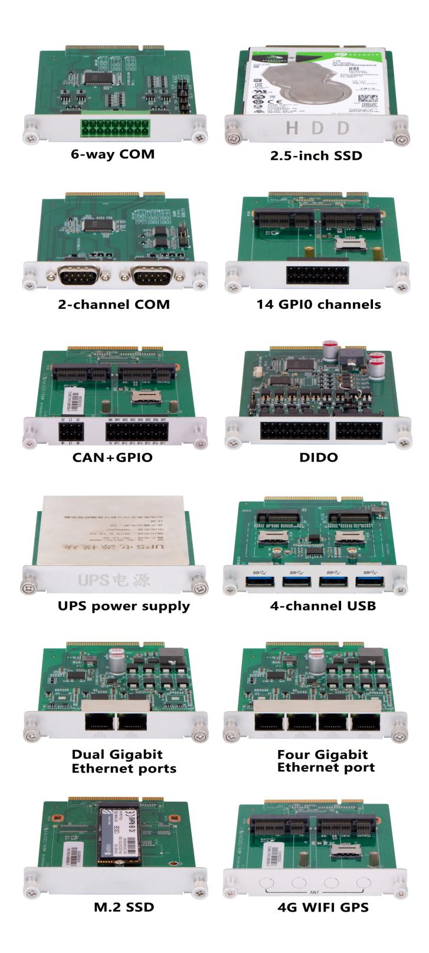
QY-B6100
4.Ordering Information:
Model | Chipset | LAN | USB | COM | Display | RAM | SSD | Expansion | Power
QY-B6100 | H670 | 2 | 7 | 4*RS-232/422/485  2*RS-232 | 1*HDMI  1*DP  1*VGA | 2*DDR 4 | 1*M.2 NVME  1*MSATA  1*SATA | 1*Mini PCIE  1*M.2  PCIE or PCI | DC 19-36V

5.System Information:

Chipset | CPU
H670 | Celeron G Series | Windows 10 / 11 and Linux
H670 | Pentium Gold Series | Windows 10 / 11 and Linux
H670 | 12th / 13th / 14th | Windows 10 / 11 and Linux

6.Fittings Information:
RAM | DDR 4 | 4GB / 8GB / 16GB / 32GB
Storage | M.2 NVME | 128GB / 256GB / 512GB / 1TB / 2TB / 4TB
Storage | MSATA | 64GB / 128GB / 256GB / 512GB / 1TB
Storage | SATA | 120GB / 128GB / 240GB / 256GB / 480GB / 512GB / 960GB / 1TB / 2TB / 4TB
GSM Module | 4G | 4G+GPS
GSM Module | 5G | 5G+GPS
WIFI Module | 7260AN / 7260AC / AX210
GPU | Power Consumption＜75W，Size small than 200mm
CAN BUS | 2*CAN BUS Ports
QY-B6100
7.Package List:
Adapter | 1*19V 10A Adapter
Power Cable | 1*Power Cable
Terminal | 2 Pin Phoenix Terminal for Power Switch
Terminal | 8 Pin Phoenix terminal for GPIO port

8.Dimensions:

